Install Document Template

Installation Manual

Installation Procedure

JDK Software and Set JAVA_HOME on a Windows System
- Install the JDK software.
  - Go to http://www.oracle.com/technetwork/java/javase/downloads/index.htmlDatabase.
  - Choose the appropriate JDK version and click Download.
The JDK software is installed on your computer, for example, C:\Program Files\Java\jdk1.8.0_60. You can change this location.
- Set JAVA_HOME :
  - Right click My Computer and select properties.
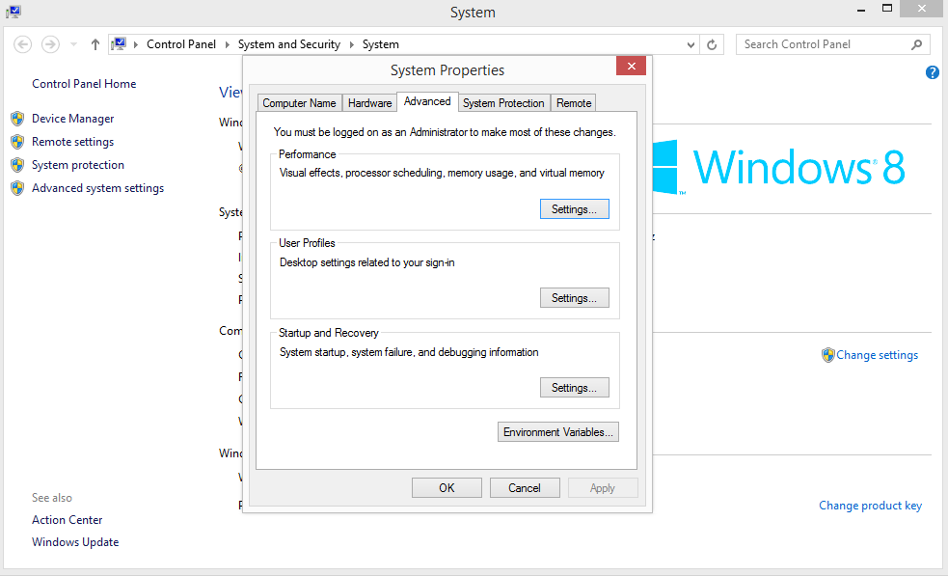
  - On the Advanced tab, select Environment Variables, and then edit JAVA_HOME to point to where the JDK software is located, for example, C:\Program Files\Java\jdk1.8.0_60.

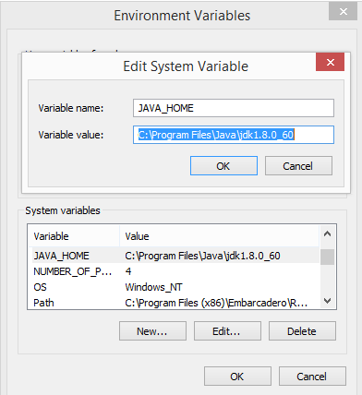

MySQL Installation:
- Download MySQL installer (for Windows) and let it install and configure all of the MySQL products on your system.
- Go to http://dev.mysql.com/downloads/installer/ , download the installer, and execute it.
- Choose the appropriate Setup Type for your system. Typically you will choose Developer Default to install MySQL server and other MySQL tools related to MySQL development, helpful tools like MySQL Workbench. Or, choose the Custom setup type to manually select your desired MySQL products.
- Complete the installation process by following the MySQL Installation wizard's instructions. This will install several MySQL products and start the MySQL server.
- MySQL is now installed. You probably configured MySQL as a service that will automatically start MySQL server every time you restart your system.

Wikipedia XML Dump File
- Go to: https://dumps.wikimedia.org/backup-index.html
- Choose the arwiki-[Date]. You need 3 files:
  - [LANGCODE]wiki-[DATE]-pages-articles.xml.bz2 or [LANGCODE]wiki-[DATE]-pages-meta-current.xml.bz2
  - [LANGCODE]wiki-[DATE]-pagelinks.sql.gz
  - [LANGCODE]wiki-[DATE]-categorylinks.sql.gz.

- Run the transformation:
  - Run the command line as administrator.
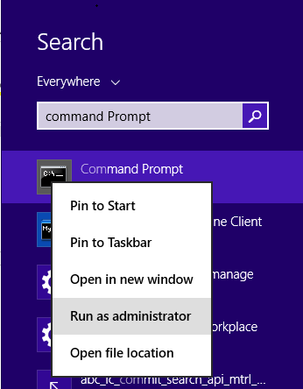

  - Type the following command: C:\Program Files\Java\jdk1.8.0_60\bin>java -jar de.tudarmstadt.ukp.wikipedia.datamachine-1.0.0-jar-with-dependencies.jar arabic Contents Disambiguation_pages E:\arwiki-20160305

[LANGUAGE]: a language string matching one the JWPL_Languages.
[MAIN_CATEGORY_NAME]: the name of the main (top) category of the Wikipedia category hierarchy
[DISAMBIGUATION_CATEGORY_NAME]: the name of the category that contains the disambiguation categories [SOURCE_DIRECTORY]: the path to the directory containing the source files
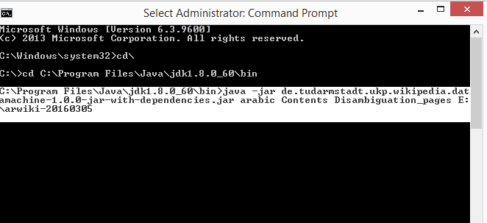

  - It will take a while… While the DataMachine is running, it creates three temporary .bin files. These are only needed during processing time and can be deleted once all files in the output directory have been produced.
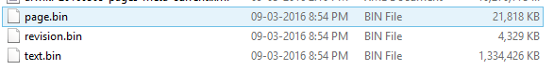
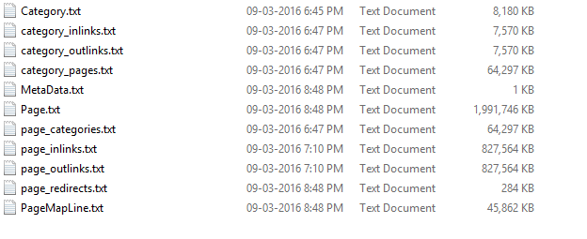
  - Eventually, you should get 11 txt files in an “output” subfolder

- Create a database with the necessary tables: CREATE DATABASE [DB_NAME] DEFAULT CHARACTER SET utf8 DEFAULT COLLATE utf8_general_ci;
- Create all necessary tables using the script:
https://github.com/dkpro/dkpro-jwpl/blob/master/de.tudarmstadt.ukp.wikipedia.wikimachine/jwpl_tables.sql
- Import the data files into the database using Load Data Command: LOAD DATA LOCAL INFILE ' arwiki-20160305/output/Category.txt' INTO TABLE Category COLUMNS TERMINATED BY '\t';

Using JWPL with Maven Project:
- Open eclipse>>File>>New>>Maven Project
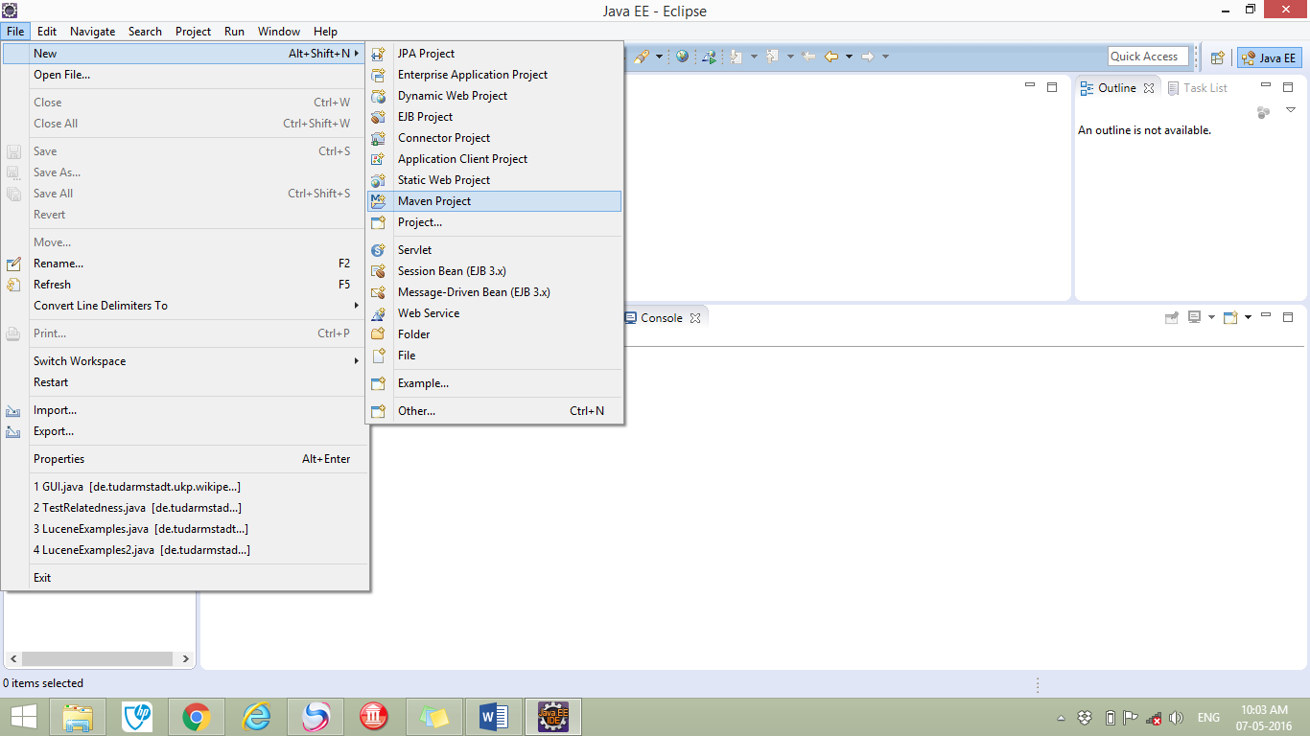

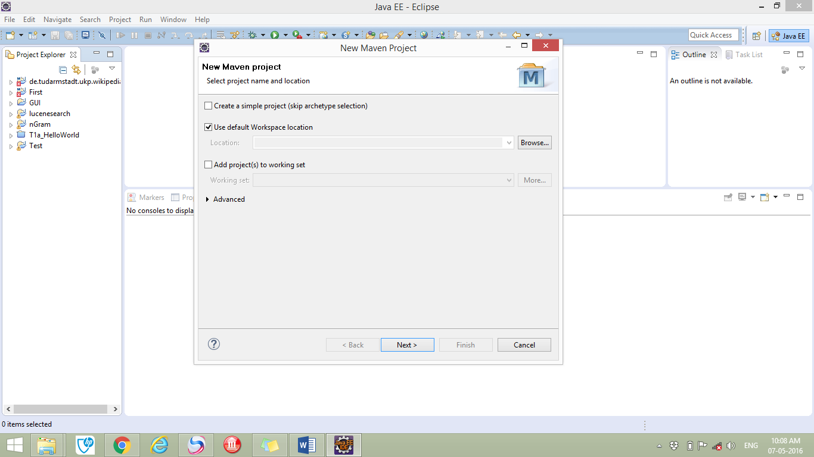

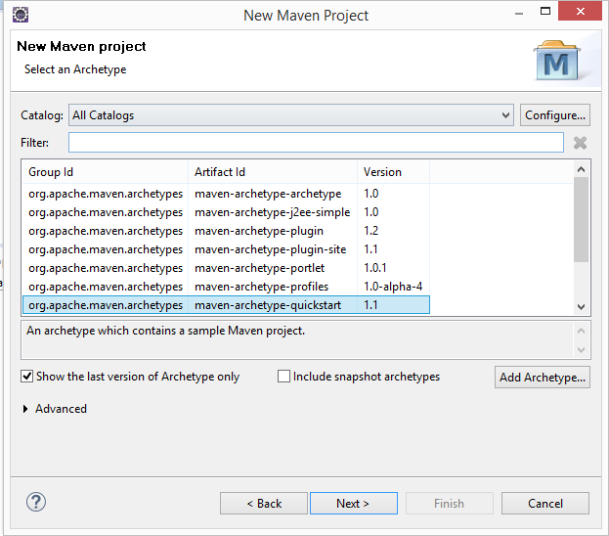

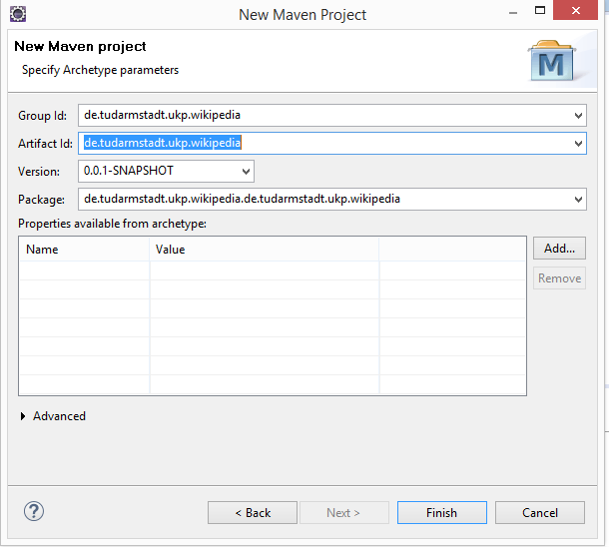

- Add dependencies to POM.xml file.
